**Ideation Phase**

**Define the Problem Statements**

|  |  |
| --- | --- |
| Date | 2 March 2025 |
| Team ID | SWTID1743689974 |
| Project Name | Book Store |
| Maximum Marks | 2 Marks |

**Customer Problem Statement Template:**

Create a problem statement to understand your customer's point of view. The Customer Problem Statement template helps you focus on what matters to create experiences people will love.

A well-articulated customer problem statement allows you and your team to find the ideal solution for the challenges your customers face. Throughout the process, you’ll also be able to empathize with your customers, which helps you better understand how they perceive your product or service.

**Example:**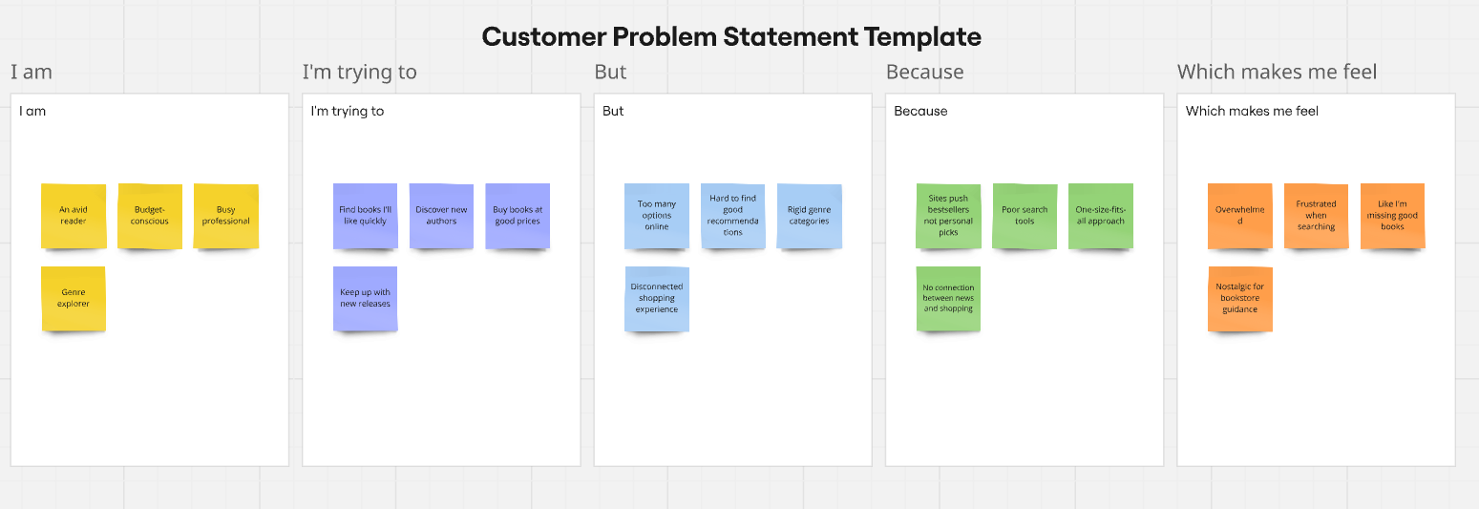

|  |  |  |  |  |  |
| --- | --- | --- | --- | --- | --- |
| **Problem Statement (PS)** | **I am (Customer)** | **I’m trying to** | **But** | **Because** | **Which makes me feel** |
| PS-1 | An avid reader | Find books I'll like quickly | Too many options online | Sites push bestsellers not personal picks | Overwhelmed |
| PS-2 | Budget-conscious | Discover new authors | Hard to find good recommendations | Poor search tools | Frustrated when searching |
| PS-3 | Busy professional | Buy books at good prices | Rigid genre categories | One-size-fits-all approach | Like I'm missing good books |
| PS- 4 | Genre explorer | Keep up with new releases | Disconnected shopping experience | No connection between news and shopping | Nostalgic for bookstore guidance |